
Practice Your Planning

Written by Roger Pfister http://RogerPf.com/aaBridge roger@rogerPf.com

This document comes as part of the 'aaBridge Document Collection' which itself, is part of aaBridge.

This document ties into the series of lessons in aaBridge that you can access via the
aaBridge Menubar > Books-L > Writer - Roger on Planning

This document is going to show you how to use the Howard Schulman mentoring hands that are included in aaBridge to Practice your Planning as if you were the declarer (and always sitting 'South').

Acknowledgements
A big thank you to Howard (hondo717) www.bridgesights.com/hondobridge for permission to use the over 2100+ played deals from his mentoring sessions. And just as big a thank you to Kia Aziz (nome) for creating the many hundreds of lin files that let us see the hands and read all of Howards comments on them.

What we are trying to achieve
The instructions that come later will let you see a hand as if you were sitting in the South seat. Next you will see the bidding for that hand and after that you will see West's lead.
At that point your next step will be to stop, think, and plan the play.

If (somehow!) you do not have aaBridge installed use the link at the top of this page to get to the website. There are also two YouTube videos that cover installation on Windows and Mac.

see https://www.youtube.com/channel/UCjqx0Cofc7-TT-N0tfYR8rg

which is the 'aaBridge Channel' on YouTube, see videos 010 and 011.

<continued on next page>
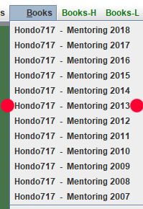
Open aaBridge and click on the menu bar. From the drop down menu select
Books -> Hondo 717 - Mentoring and 2013

The first 'Mentoring Tutorial' for 2013 will now open, mentoring1301a.

( The mentoring tutorials were written to run on other software. So ignore any instructions to click 'strange' buttons. Instead YOU move by using the two Flow > buttons and by clicking on the Navigation Bar that you can see below those two buttons ).
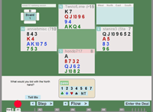

Click the Flow > button twice OR click the bump on the navigation bar labelled A1 as shown below, Red DOT. You should now be looking at board 1 of mentoring1301a.

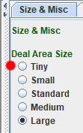
If you have a large monitor you may find that the hand diagrams appear too large for comfortable viewing. You can reduce the size of the hands while keeping the display text and the Flow > buttons at normal size.

At the top of the far right hand column select Size & Font and click on Tiny (red dot above).

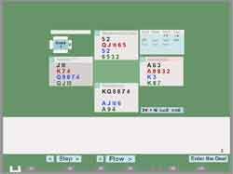

(An example deal showing with the Tiny option selected)

The Size & Font setting is purely optional and you can change it at any time.

<continued on next page>

Setting up aaBridge for 'True Table' Simulation
If you do not have aaBridge open and currently displaying the first mentoring tutorial of 2013 then please follow the instructions on the previous page to have it showing.
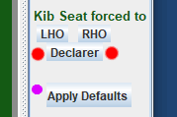
To assure that when entering a deal we only see the hand we want to see, we need to set the Kib Seat forced to option
Click the Declarer button (two red dots).
Later when you want to use aaBridge for other things you can click the Apply Defaults button (with the permanent pink dot) to quickly restore the normal settings.

From now on, whenever you click the Enter the Deal button the Declarer will be rotated to the south zone and the other three hands will be hidden from you and the bidding will be about to commence.

When you click the Flow > button or the single button ">" (and optionally THEN use your mouse wheel) each bid will be shown to you. Once the bidding has finished your left hand opponent will lead and the dummy will appear.

Test that this works by clicking on the Navbar – best to click in the middle between the bumps (deals) marked A1, A2 etc. Then ...

click on Enter the Deal and see that you can view the bidding and play in order.

click on Back to Movie to return to the movie and then try entering another deal.

But there is a problem - to get into each deal you will sometimes, when you first click to enter the deal, catch a glimpse of all the other hands in the deal. Now do the same as before...
but - this time please use the right mouse button to click between the tabs.

The right mouse button will both take you to the deal at that point and do an Enter the Deal for you. Please practice doing this a few times, return using the Back to Movie button.

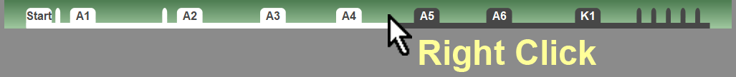

( If you do NOT have a 'right mouse button', try not to notice the cards and quickly click Enter the Deal )

An Example
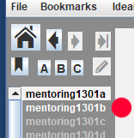
In the right hand column click on mentoring1301b (red dot).

As you have learnt, use the right mouse button and click in the middle between A4 and A5 on the navbar.

Click the single forward button ">" and then (if you have one) switch to using your Mouse wheel to step forwards (or back) through the bidding.
You will watch Hondo bid to 4 Diamonds and Stan will lead the King of Spades.

This example is a simple one when it comes to planning (and yes, a game contract of 3NT would have been much nicer).

The Standard Drill
Don’t forget to do the standard drill as you watch the bidding unfold.

When Stan doubles your opening 1♦ bid say to yourself 8+ hcp and should be at least 4-3 in the majors.
When partner bids 1♥ think 4+ card in hearts and 7+ hcp etc...

If you do not consciously think of the meanings of each bid as they are made the information will have faded in your mind when you need it to do your planning.

For the actual steps of planning, I am going to refer you back to (still being written) series:
aaBridge Menubar > Books-L > Writer - Roger on Planning
Sometimes you will need to play out a trick or two before you know where you stand e.g. Opps are about to run the top few tricks in no trumps. You can review the cards played at the table OR click on the Play button and play your own cards against the aaBridge bots.
WARNING - try to complete your planning – this is Planning not PLAY Practice.

PLEASE - read the Hints and Tips on the next page.

Hints and Tips

Low Level Contracts
The lower the contract the harder it is to plan, so when starting to practice, I suggest you concentrate on 3 level contracts and higher. Skip the 1 and 2 level contracts for now.

Bookmarks
aaBridge has a bookmark system. Click the second item on the menubar "Bookmarks" and read how it works. Ideal for remembering where you have got to in the mass of mentoring hands.

Counting
Good planning is a prelude to good play and that often requires counting. So if you do choose to play out the hand – try – please do try – to "count the hand" as best you can.

For counting practice exercises see the Doc Collection document

Memorize Suit Distributions - a How to.doc

and the aaBridge YouTube channel

https://www.youtube.com/channel/UCjqx0Cofc7-TT-N0tfYR8rg

and look for the video

- Learning to count the unseen hands using aaBridge

<End of document>

